Supplementary material

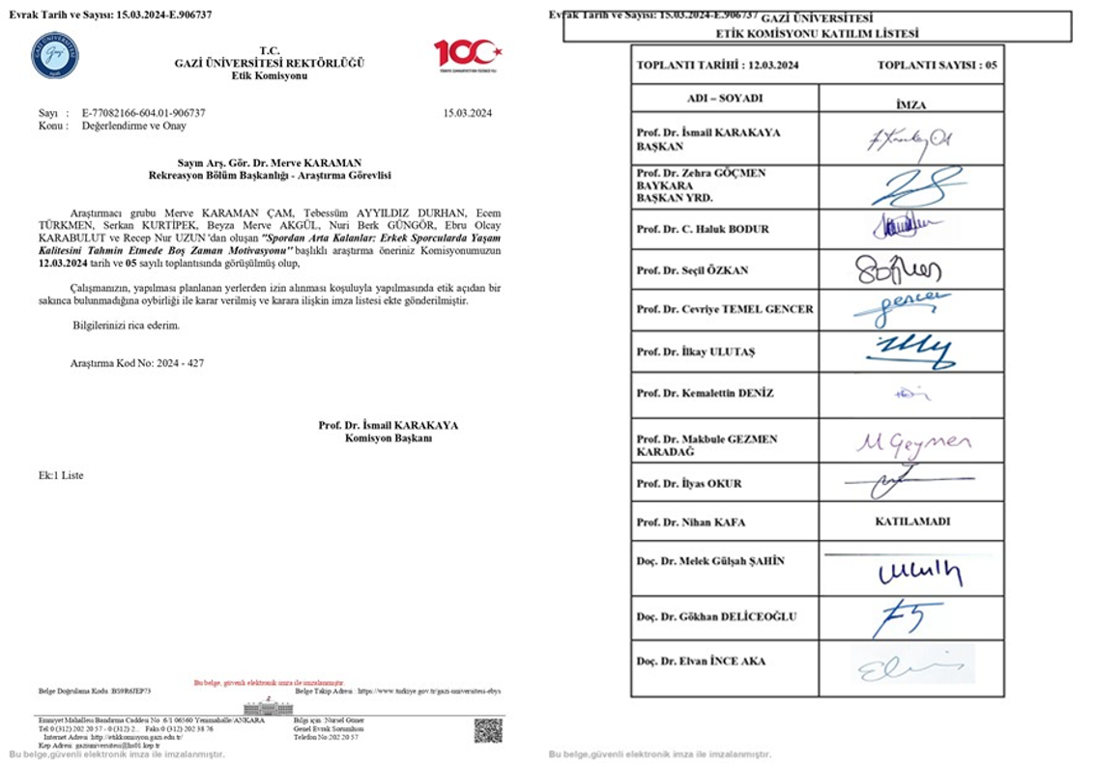
Supplementary Fig. 1. Ethics committee consent forms.

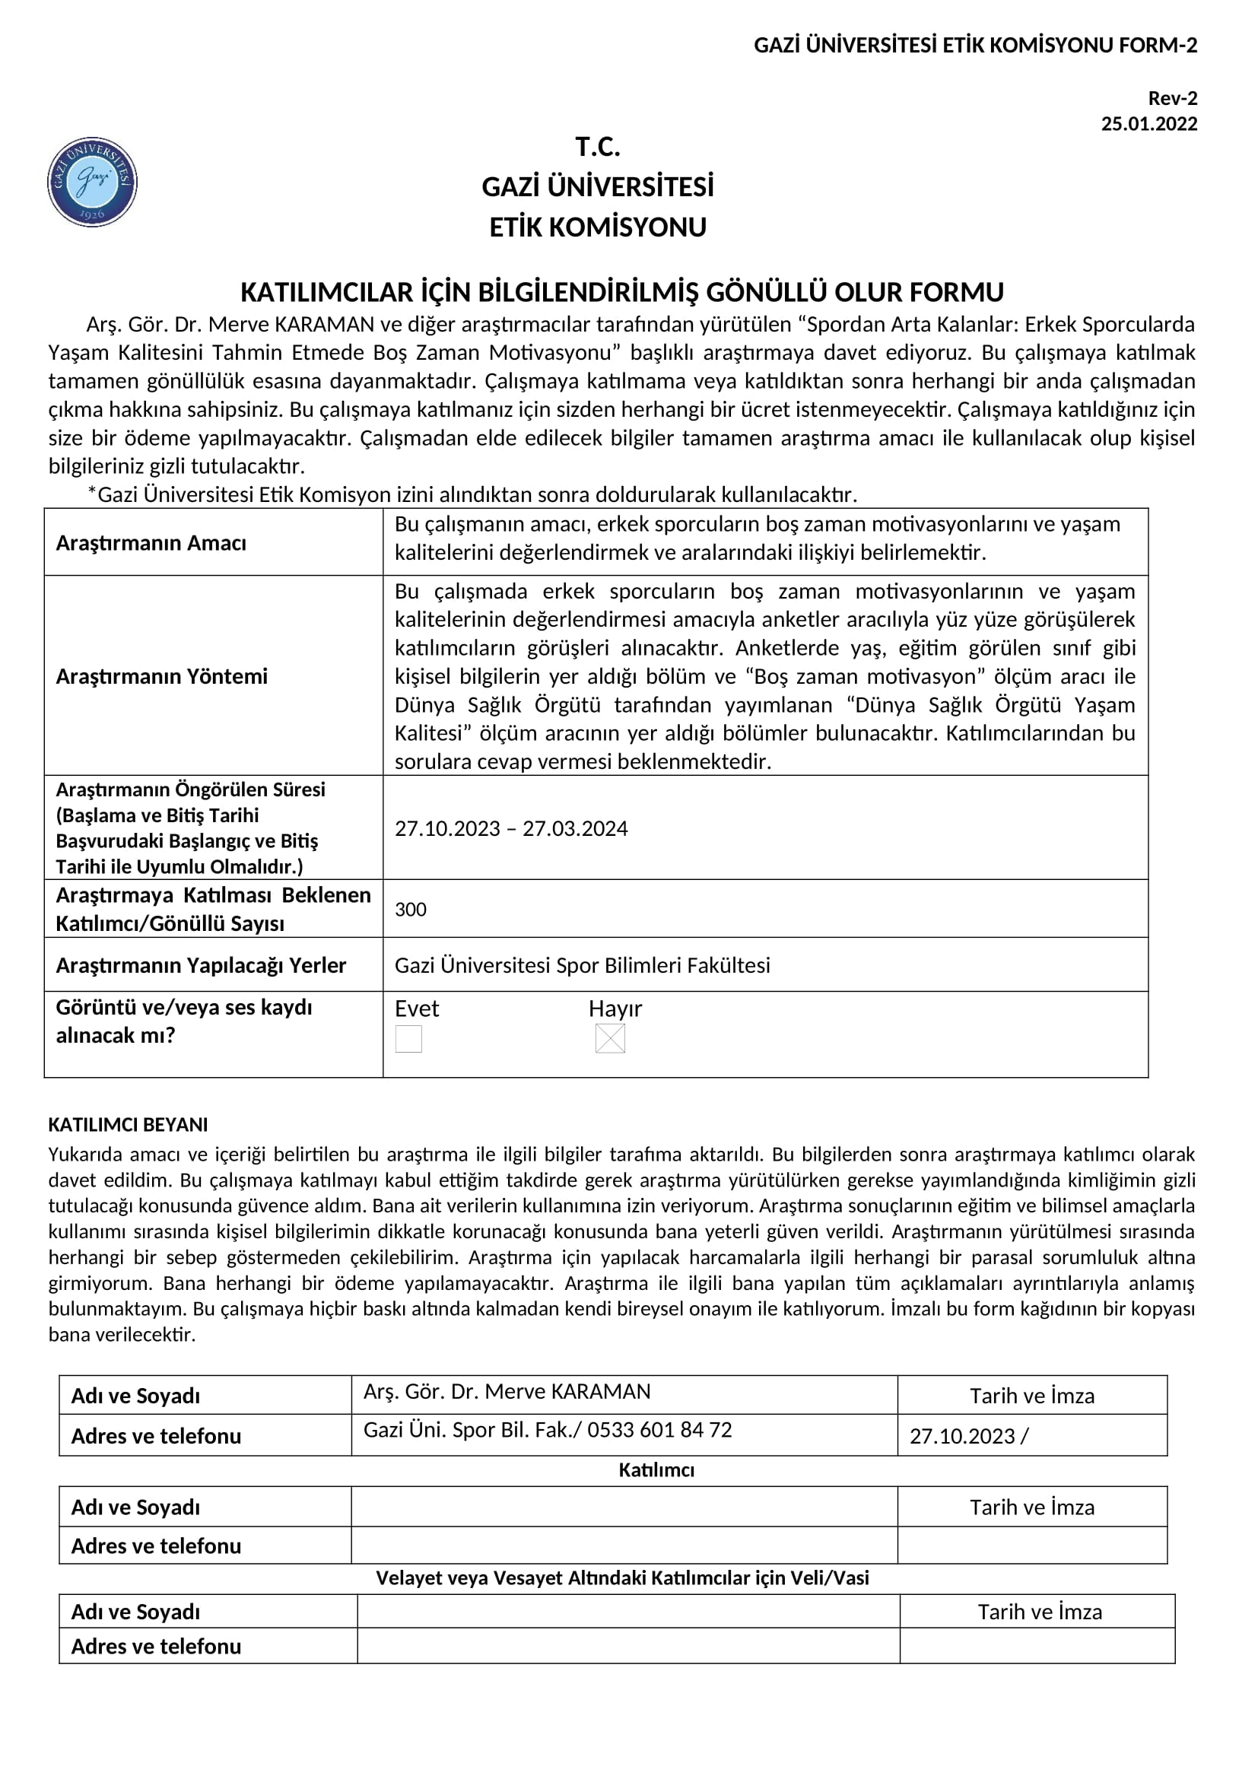
Supplementary Fig. 2. Voluntary consent form.

